Individual Scholarship Application

As part of the application process, we want to know more about you and the work you are doing (or aspire to do)in your community. To qualify for a scholarship with Childbirth International you need to be personally a part of a marginalized community and be planning to work within that community. Applicants can apply for one course at a time and, if successful, must complete the course before applying for a second scholarship opportunity.

Once we receive your application we will add your application to our review queue. We review applications as they come in and add them to the lottery if they meet the requirements. Applicants will be notified in the first week of the draw whether their application was successful. The scholarship lottery awards up to 3 scholarships every 2 months with draws taking place in February (for December, January), April (for February, March), June (for April, May), August (for June, July), October (for August, September), December (for October, November).

Thank you for your application.

Regards,
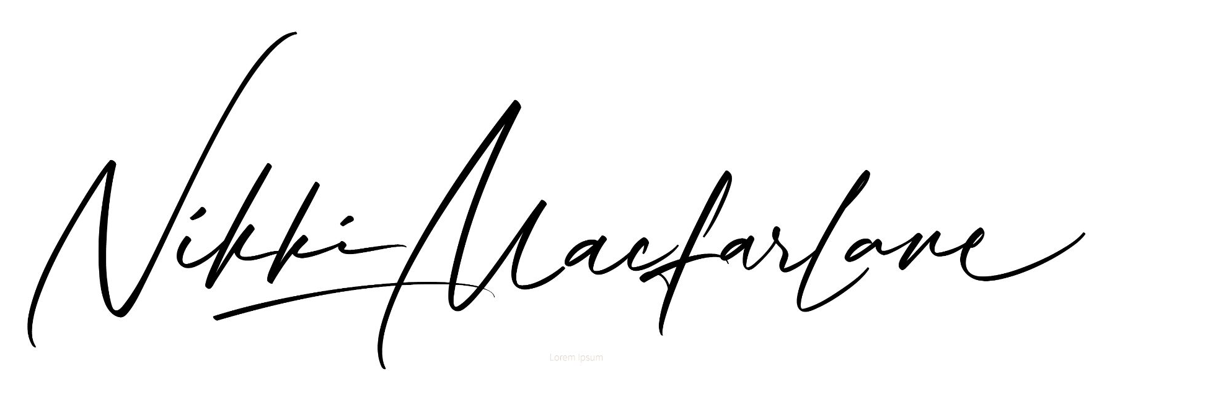
Nikki Macfarlane (she/her/hers)
Founder and CEO, Childbirth International

Applicant’s personal information
Name:
Pronouns:
Location:
Course Applying For:
Email:
Date Submitted:

Once you’ve completed all the questions on this form please return the completed document to Childbirth International by email to scholarships@childbirthinternational.com. Please be sure to answer the questions in a word processing program.

Please identify the following about yourself:
Please identify which marginalized community you are personally a part of:

BIPOC (Black, Indigenous, Person of Colour)
LGBTQIA2S+ (Lesbian, Gay, Bisexual, Transgender, Queer, Intersex, Asexual, Two-Spirit)
Disabled
Other (please share):

Which course are you applying for?

Birth Doula
Postpartum Doula
Childbirth Educator
Lactation Counselor

Would you want to:

Pay in full
Pay in 5 monthly payments
Pay in 10 monthly payments

All CBI students have access to their course materials online through the student website. If choosing to pay in full, printed manuals may be purchased (additional cost). If choosing to pay by instalments, printed manuals may be purchased once all instalments have been completed.

Your choice of payment does not affect your eligibility for a scholarship but lets us know how we can set you up in our system and get you into your course as efficiently as possible if you are successful in the lottery.

Personal Reflection:
Childbirth International offers online courses that are primarily text-based and entirely self-paced. Students will be able to access your course through our student website and affiliated Moodle app. Students are paired with a trainer who will be available by email to answer any questions they have and the trainer will also provide personal feedback on all written assignments within 14 days of their submission. Students are responsible for finding the clients they will work with to complete their course requirements.

Please check the boxes to indicate your understanding of the following:
I understand that Childbirth International courses are self-paced and online. My assigned trainer will provide feedback on my assignments as and when I submit them.
I understand that, if I am successful, the scholarship covers 50% of the course fees and that printed manuals and shipping costs (if I choose them) are additional costs that I am responsible for.

Our scholarship lottery is open to individuals who identify as part of a marginalized group and who want to (or are already) working within that community to support parents and families.

Please share what work you are doing in your community, or the work that you would like to do when you complete your training, and how CBI can support you in meeting your goals.

Please provide any additional information that you feel would be helpful in reviewing your application.

__________________________________
Signature of applicant and date signed

